Project Design Phase-II
Data Flow Diagram & User Stories
Date | 20 July 2026
Team ID
Project Name | ShopEZ : E-commerce Application
Maximum Marks | 4 Marks
Data Flow Diagram
A Data Flow Diagram (DFD) is a traditional visual representation of the information flows within a system. It shows how data enters and leaves the system, what changes the information, and where data is stored.
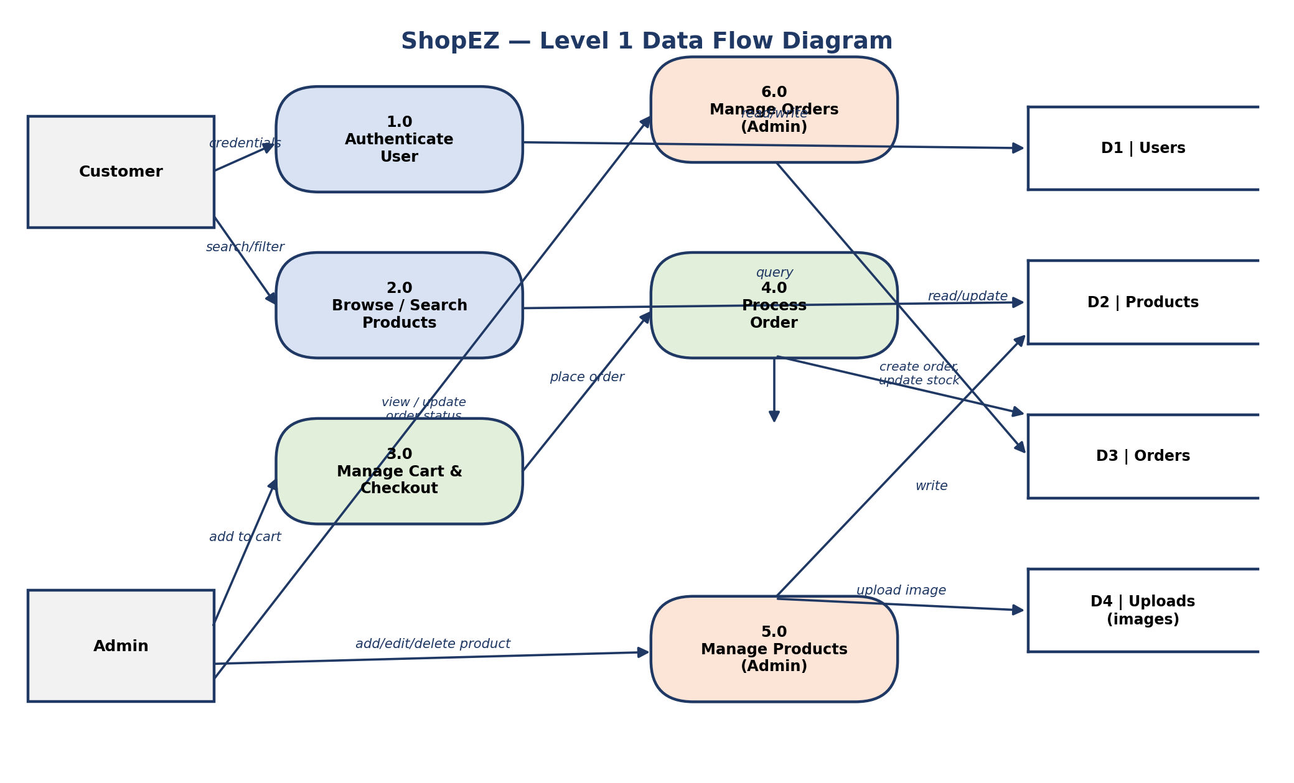
Figure 1: ShopEZ Level-1 Data Flow Diagram — Customer and Admin interactions with the authentication, catalog, cart/checkout, and order-management processes, and the underlying Users / Products / Orders / Uploads data stores.
User Stories
The following table lists the user stories for the ShopEZ product.
User Type | Functional Requirement (Epic) | User Story Number | User Story / Task | Acceptance Criteria | Priority | Release
Customer | Registration | USN-1 | As a user, I can register for the application by entering my name, email, and password. | I can create an account and am logged in / can access my profile. | High | Sprint-1
Customer |  | USN-2 | As a user, I can register using a strong password of at least 6 characters, and receive a clear error if it is too short. | I see "Password must be at least 6 characters" if my password is too short. | Medium | Sprint-1
Customer | Login | USN-3 | As a user, I can log into the application by entering my email & password. | I receive a JWT token and am redirected to the Home page. | High | Sprint-1
Customer |  | USN-4 | As a user, I see a clear error if I enter invalid credentials. | I see "Invalid email or password" and remain on the login page. | Medium | Sprint-1
Customer | Product Catalog | USN-5 | As a user, I can browse all available products on the Home / Products page. | The full product list loads with name, image, price, and category. | High | Sprint-1
Customer |  | USN-6 | As a user, I can search for products by name or keyword. | Only matching products are displayed as I type/submit a search. | Medium | Sprint-1
Customer |  | USN-7 | As a user, I can filter products by category. | Only products in the selected category are shown. | Medium | Sprint-1
Customer |  | USN-8 | As a user, I can view a product's detail page with price, description, and stock. | The detail page shows accurate, up-to-date product information. | High | Sprint-1
Customer | Cart | USN-9 | As a user, I can add a product to my cart and update or remove items. | Cart totals update instantly and reflect my changes. | High | Sprint-2
Customer |  | USN-10 | As a user, my cart persists between browser sessions. | My cart items are still present after I refresh or reopen the app. | Medium | Sprint-2
Customer | Checkout | USN-11 | As a user, I can check out my cart to place a real order. | An order is created, stock is decremented, and my cart is cleared. | High | Sprint-2
Customer |  | USN-12 | As a user, I am warned if I try to order more than the available stock. | I see "Insufficient stock for <product>" and the order is not placed. | Medium | Sprint-2
Customer | Dashboard / Profile | USN-13 | As a user, I can view and update my profile and see my past order history. | My profile page shows my details and a list of my past orders. | Medium | Sprint-3
Customer (Web user) | Cross-platform Access | USN-14 | As a web user, I can access ShopEZ from any modern desktop or mobile browser. | The responsive UI renders correctly on both desktop and mobile screens. | Low | Sprint-3
Customer Care Executive | Order Support | USN-15 | As a customer care executive, I can look up a customer's order to help resolve queries. | I can view order details (items, status, total) when logged in as Admin. | Low | Sprint-4
Administrator | Product Management | USN-16 | As an admin, I can add, edit, and delete products, including uploading a product image. | New/updated products appear correctly in the catalog with their image. | High | Sprint-3
Administrator | Order Management | USN-17 | As an admin, I can view all customer orders and update their status. | The order list shows every order; status changes are saved and visible. | High | Sprint-4
Administrator | Access Control | USN-18 | As an admin, I have an ADMIN role so I can access protected admin-only routes that regular users cannot. | Non-admin users are denied (403) when attempting admin actions. | High | Sprint-1

